DAY 26 REPORT
TASK - Online Shopping Sales Data Analysis using DAX and Quick Measures in Power BI
Objective
The objective of this task was to understand and implement DAX calculations in Power BI by creating calculated columns, measures, and quick measures. The analysis was performed using an Online Shopping Sales dataset containing information such as customer details, product categories, quantity, sales amount, payment methods, and delivery status.
Introduction
In this task, various DAX functions were applied to analyze sales performance and categorize business data effectively.
Dataset Description
The dataset used for this analysis consisted of the following fields:
- Order ID
- Customer Name
- Product Category
- Product Name
- Quantity
- Price
- Total Amount
- City
- Gender
- Payment Method
- Delivery Status
- Order Date
These fields provided sufficient information to perform sales analysis and create meaningful calculations.
Tasks Performed
1. Data Import
The Online Shopping Sales dataset was imported into Power BI Desktop. The data was checked for accuracy and loaded successfully into the Power BI environment for further analysis.
2. Creation of Calculated Columns
Two calculated columns were created using DAX formulas.
Order Value Category
This column was created to classify orders based on their total sales amount.
- High Value
- Medium Value
- Low Value
This classification helped in identifying orders that generated higher revenue.
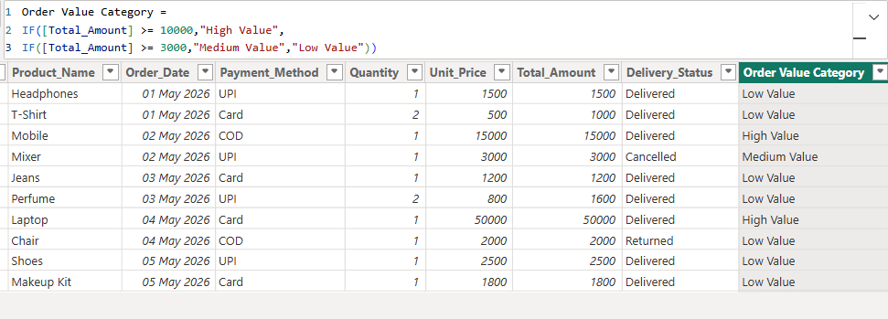
Delivery Performance
This column was created based on the delivery status of orders.
- Successful
- Unsuccessful
This categorization helped in evaluating the effectiveness of order delivery operations.
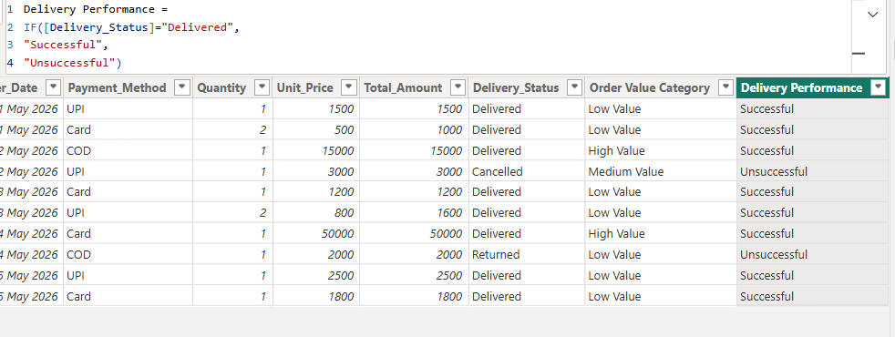
3. Creation of Measures
Several measures were created to summarize important business metrics.
Total Sales
The Total Sales measure was used to calculate the overall revenue generated from all orders in the dataset.
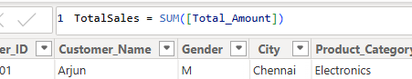
Total Quantity Sold
This measure calculated the total number of products sold across all transactions.
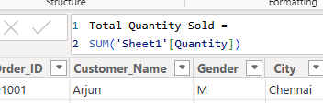
Delivered Orders Count
This measure counted the number of successfully delivered orders, helping to evaluate delivery performance.
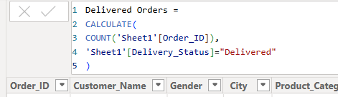
4. Implementation of Quick Measures
Power BI Quick Measures were used to perform advanced calculations without manually writing DAX formulas.
Average per Category
This quick measure calculated the average sales amount for each product category. It helped in understanding which categories performed better on average.
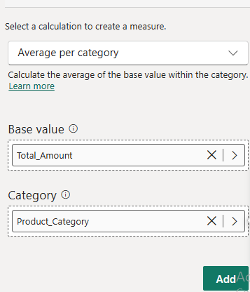
Total for Category
This quick measure calculated the total sales amount for each product category. It provided category-wise sales insights and helped identify high-performing product categories.
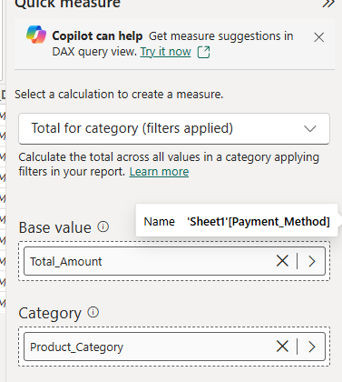
Observations
- Sales data was successfully categorized into different order value groups.
- Delivery performance was easily analyzed using the calculated column.
- Total sales and quantity sold provided a clear overview of business performance.
- Category-wise averages and totals helped compare product category performance.
- Quick Measures simplified complex calculations and improved analytical efficiency.
Outcome
By using DAX calculations and Quick Measures, meaningful business insights were generated from the online shopping sales dataset. The task improved understanding of calculated columns, measures, and category-based analysis techniques in Power BI.
Conclusion
This activity provided practical experience in using Power BI for data analysis. Calculated columns, measures, and Quick Measures were successfully implemented to analyze sales data and derive useful business information. The task enhanced knowledge of DAX functions and demonstrated how Power BI can be used to transform raw data into valuable insights for decision-making.

